|  |
| --- |
| Hanyang Univ. |
| RNN |
| Deep Learning HW#3 |

|  |
| --- |
| Sung Ki Hun  2019-6-14 |

1. **PSNR / LOSS**

* 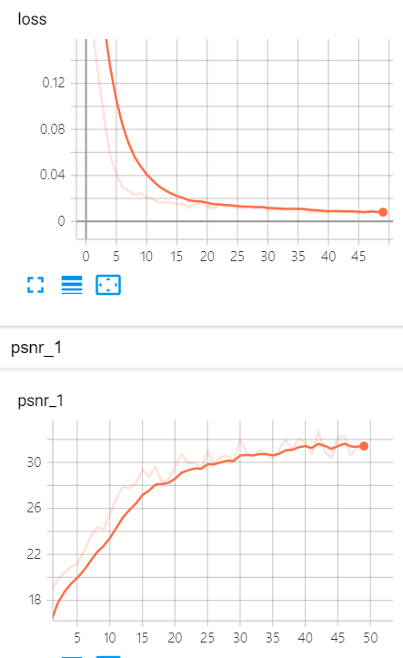

1. **Tries to do optimization**

* Changed learning rate from 1e-3 to 5e-5
* Changed stddev from 5e-2 to 1e-1
* Normalized data as 0-255 to 0-1
* 70% Train set 30% Test set on each iteration
* Removed bias from RNN

1. **Tries to do optimization**

* Batch Normalization & Higher learning rate
* L2 Normalization
* …